

**Java Institute for Advanced Technology**

WEB PROGRAMMING 1H7DT

H7DT 04/EX/01

D.M. Thamoddya Rashmitha

200509104610

Kurunegala Branch

Bison



**UI Screenshots and Explaining Code**

First User go to Main page and go to login page and select their role and login.



Login Page

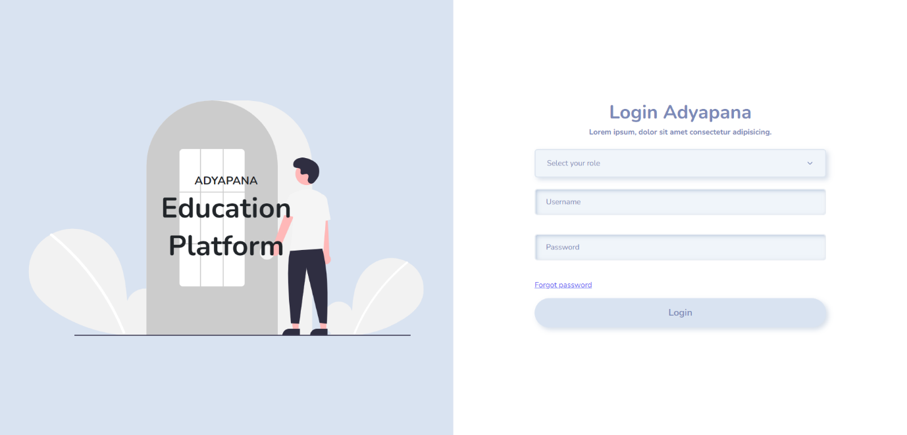

After typing the username and password and selecting the role I make ajax and use php to validate that data from server side.If there are any error occurred , It will show like this,

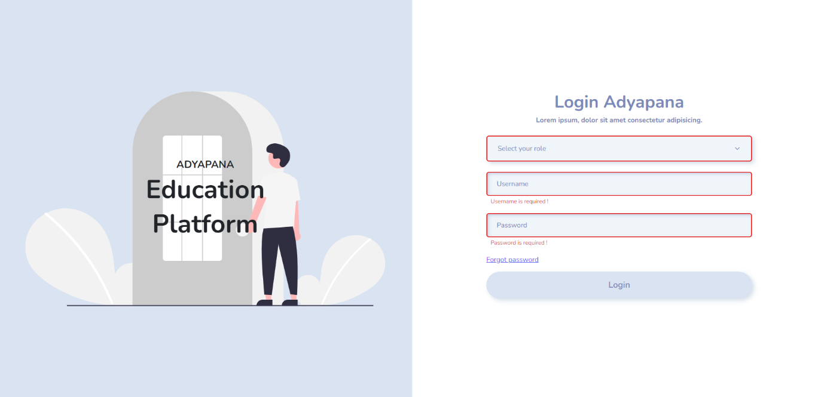

Main Function created by me to make responses and requests easy for me.Code is below,

This login function ,calls ajaxpost function and send the data as parameters and do othere thigs.if any error comes with response it calls error function and is not it call viewResalt and do othere redirections.

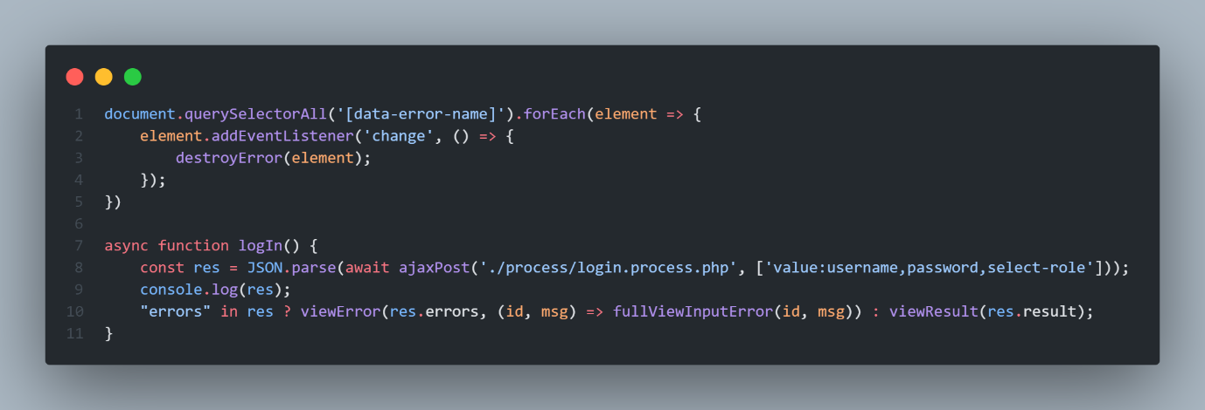

The Main function is below ,

This javascript code handles all the errors , all the requests and responses with server.

To funcition ajaxPost , I create it to make my process easy and I share the location path (‘process/loginProcess.php’) and data as array , It will automatically create a formdata and make a request to given path and get the JSON response and do othere work.

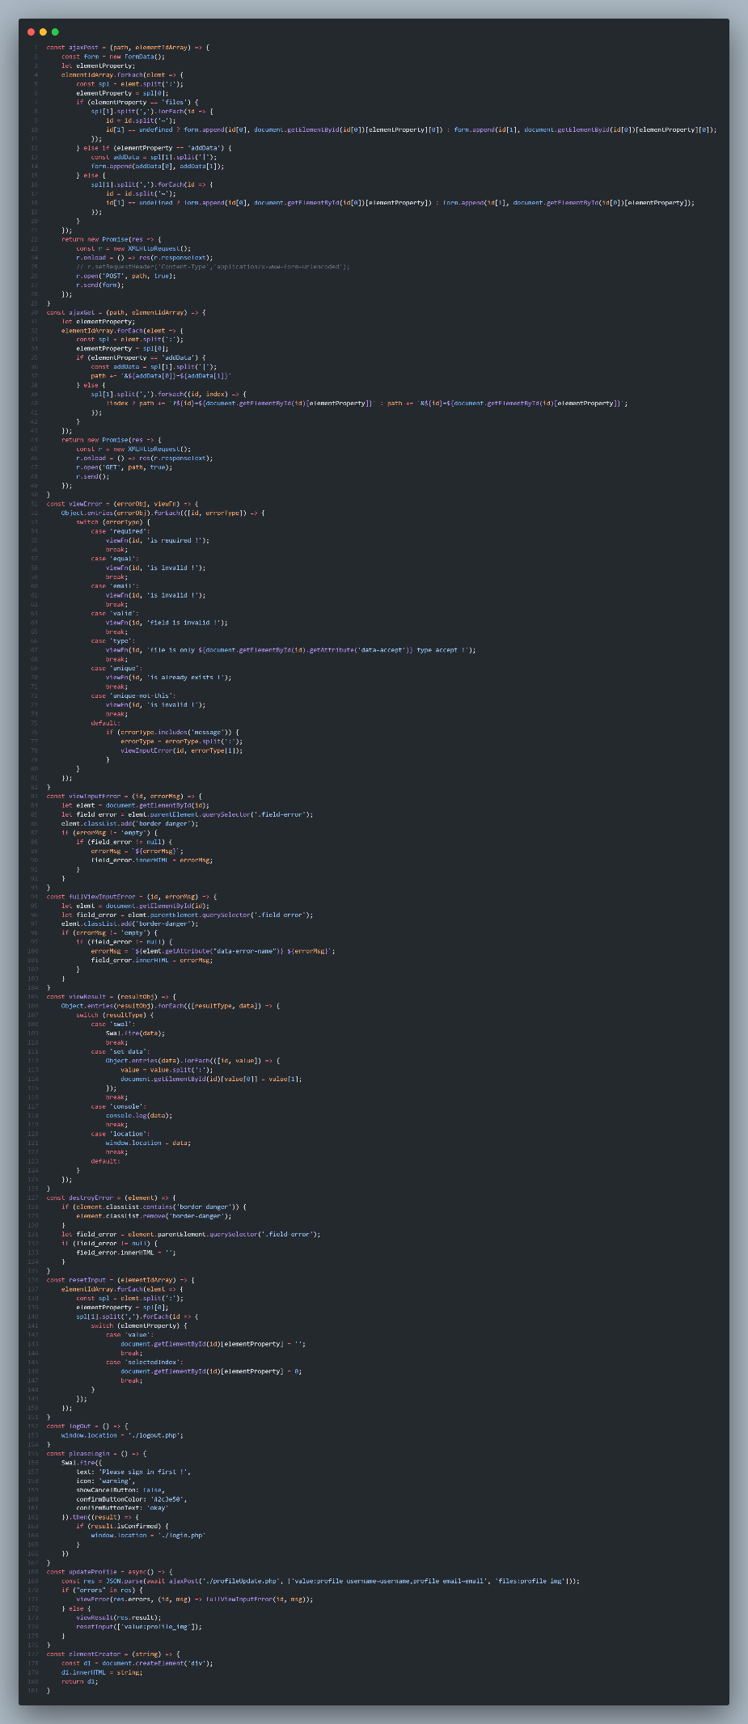

This is the PHP code to validate user login,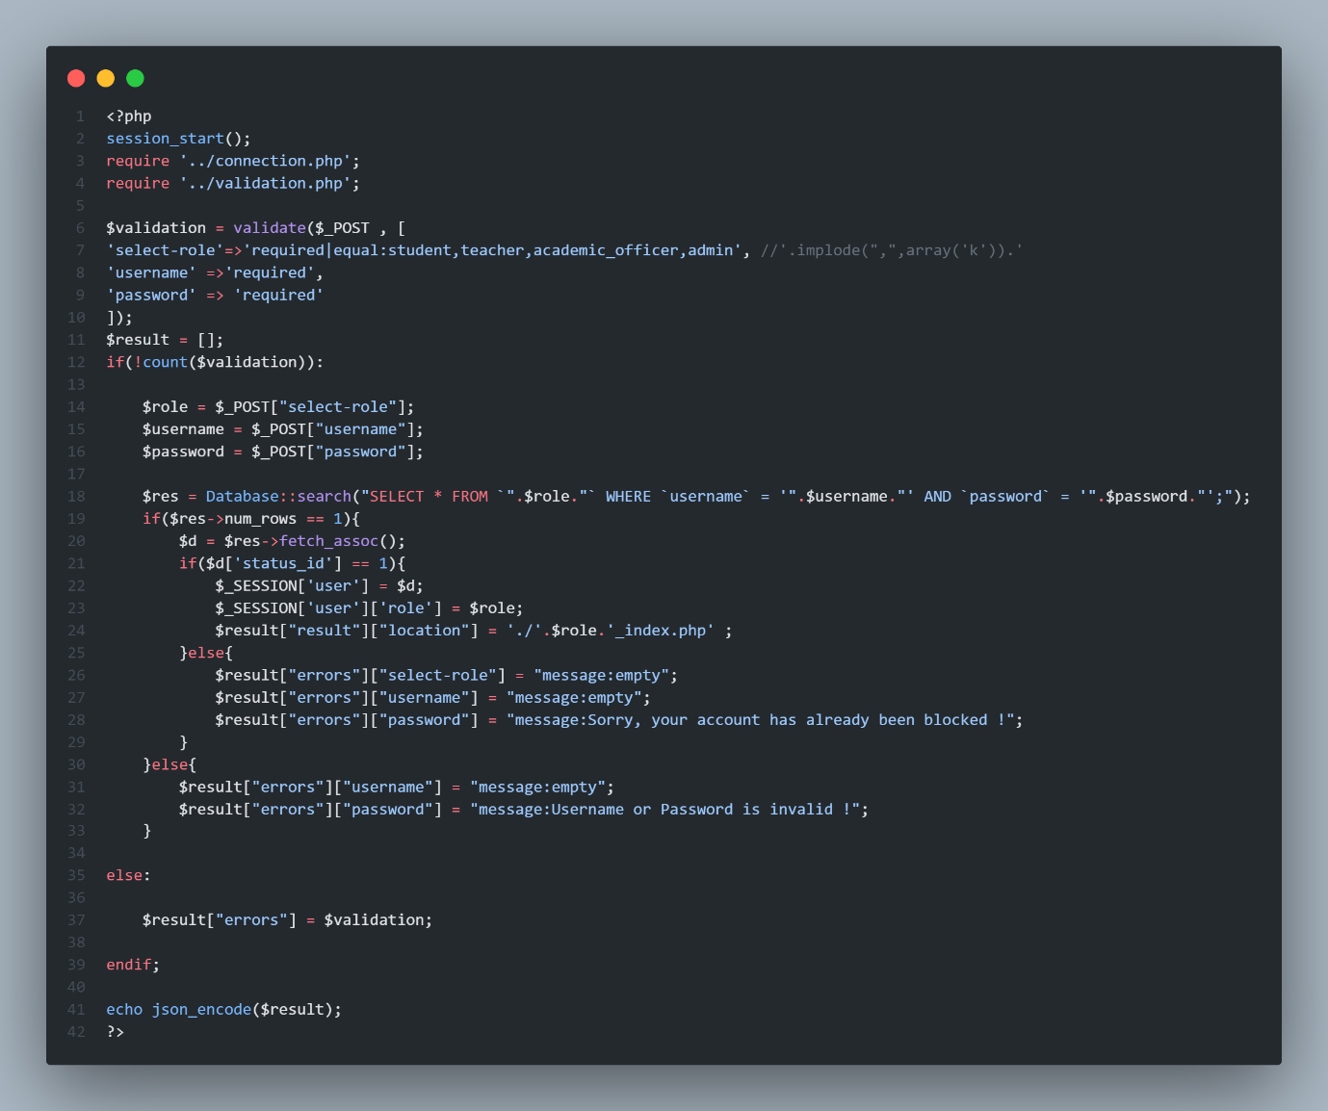This is the validate function create to validate user data like : email is a real email , password ,emailistyped , password is typed , role is selected etc..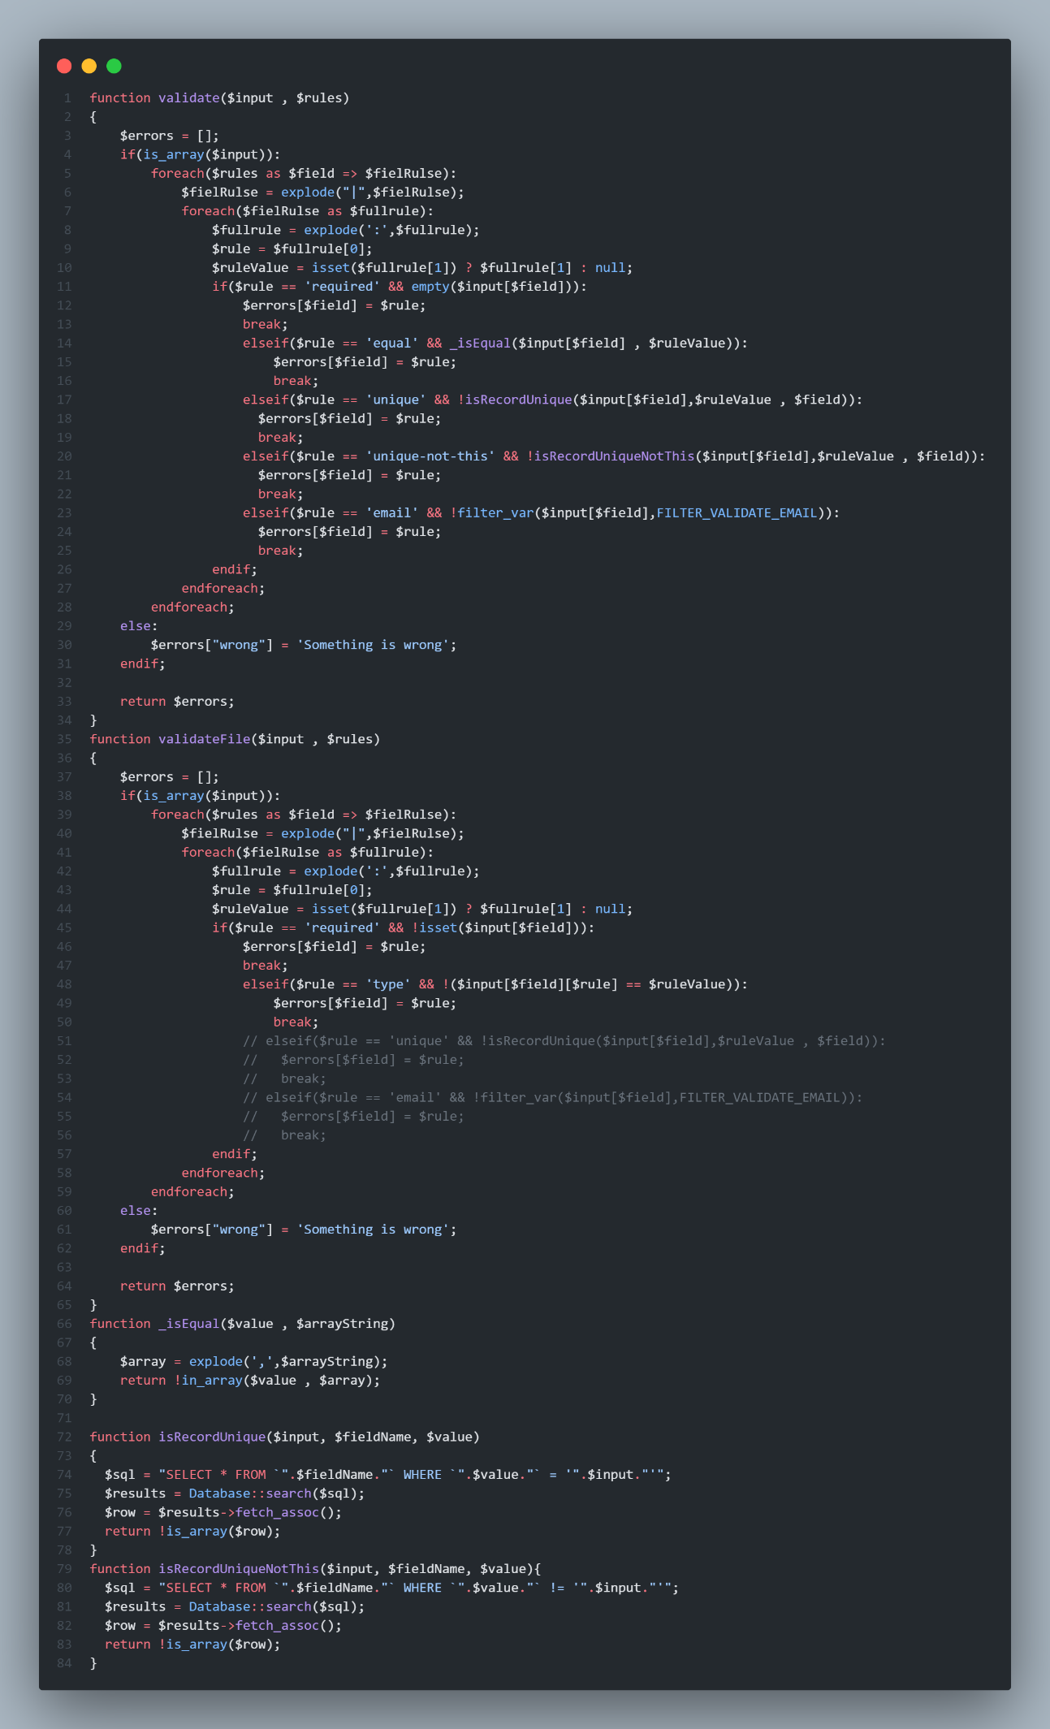

The example how to parse data to this function is on the file validate.php.

This is admin page screenshots.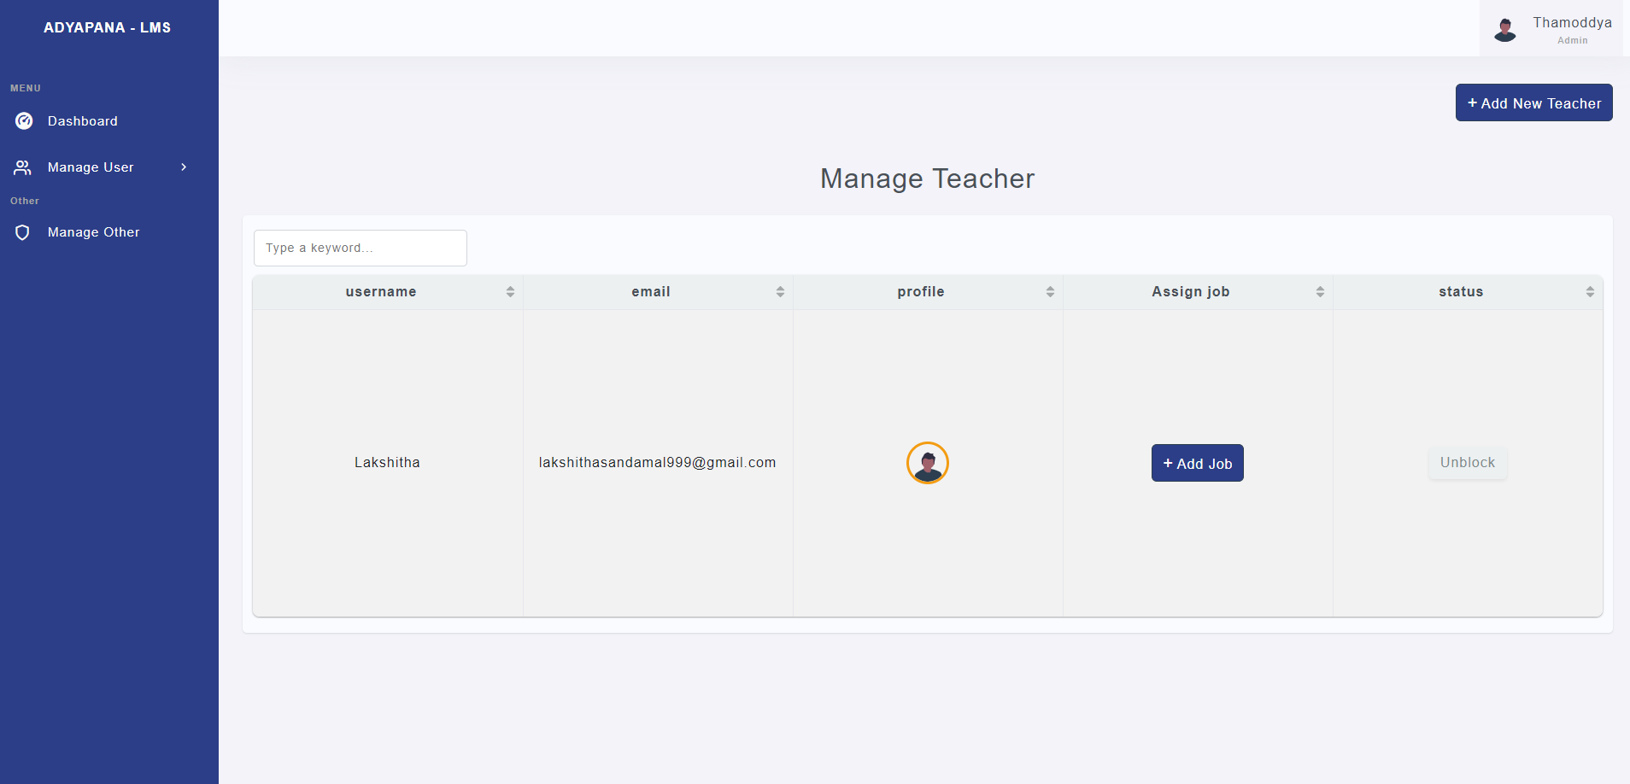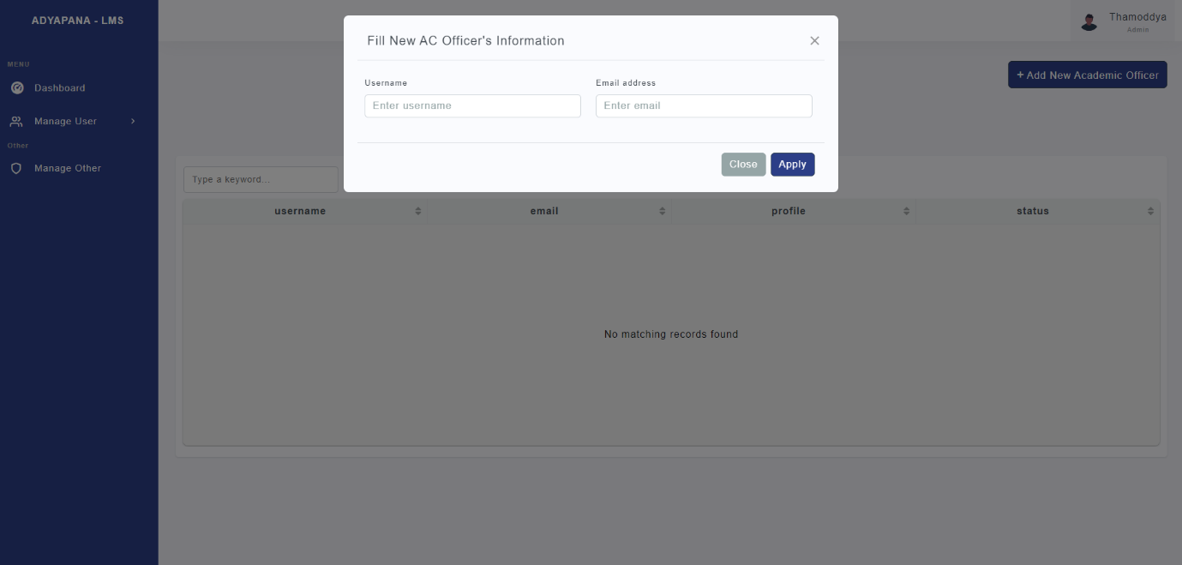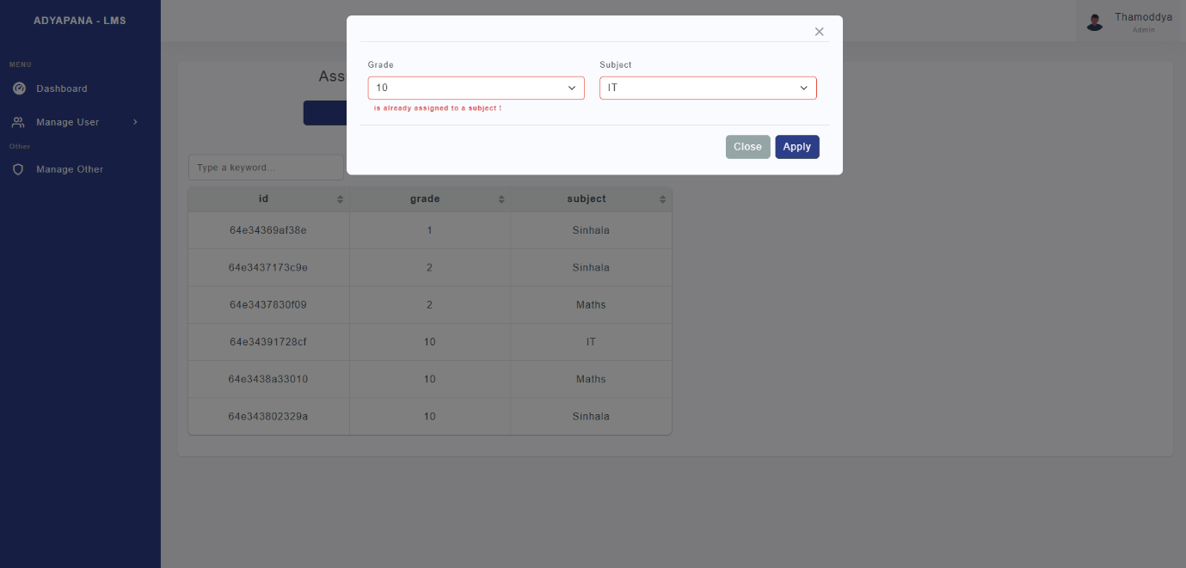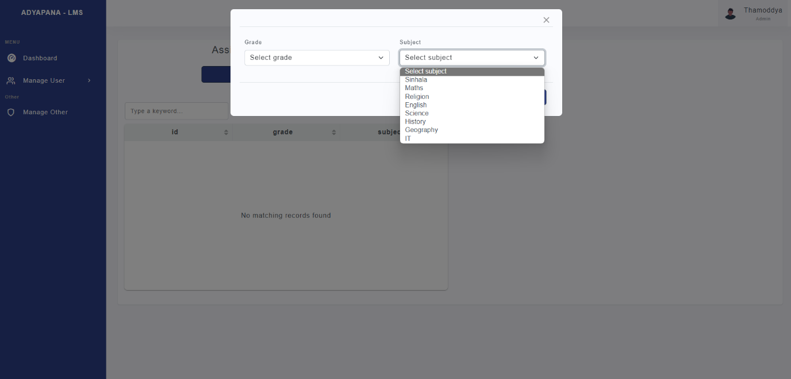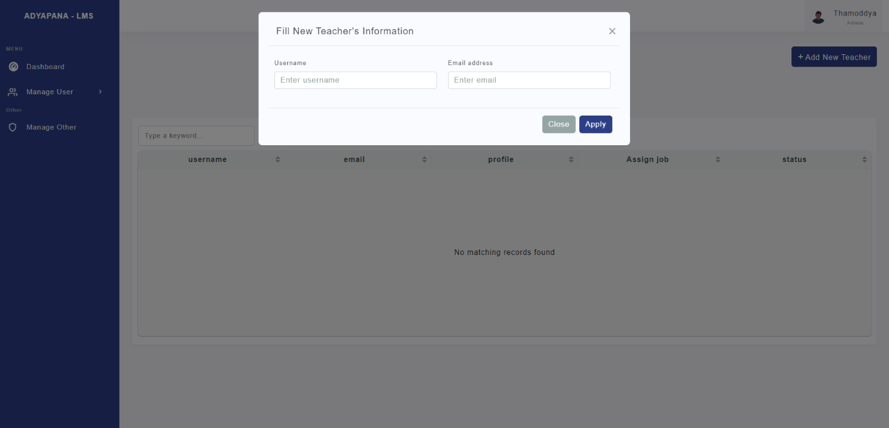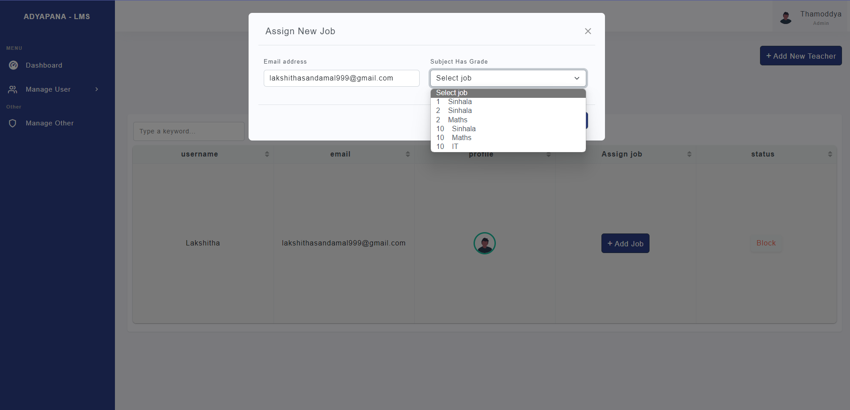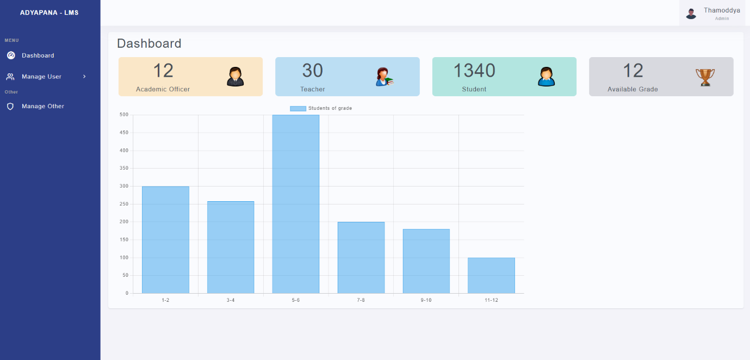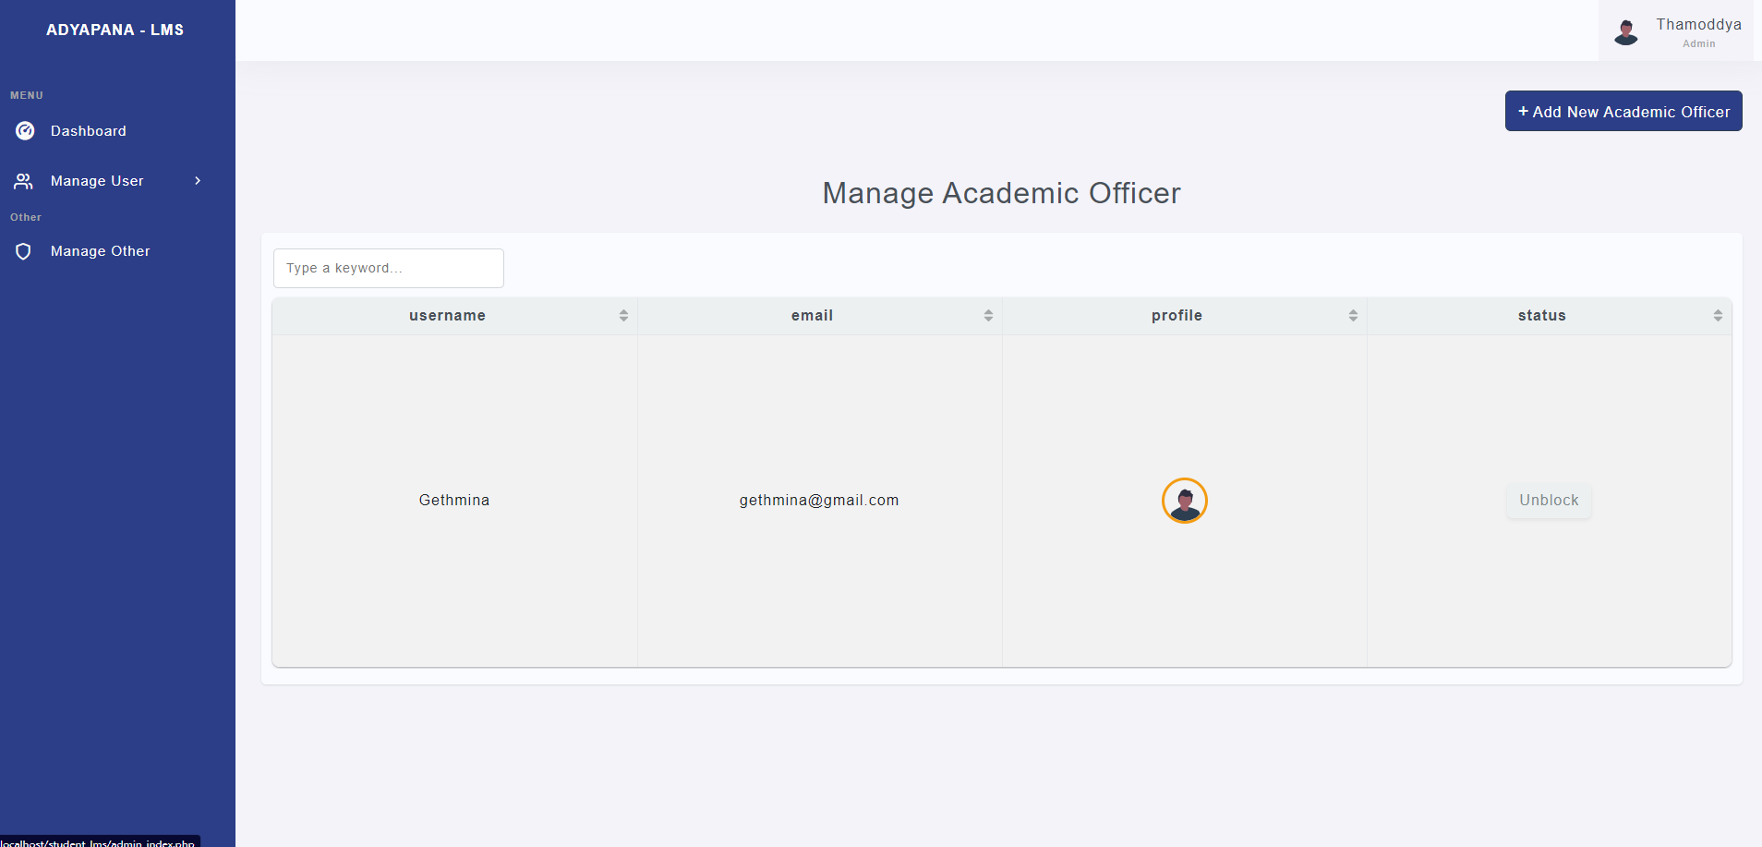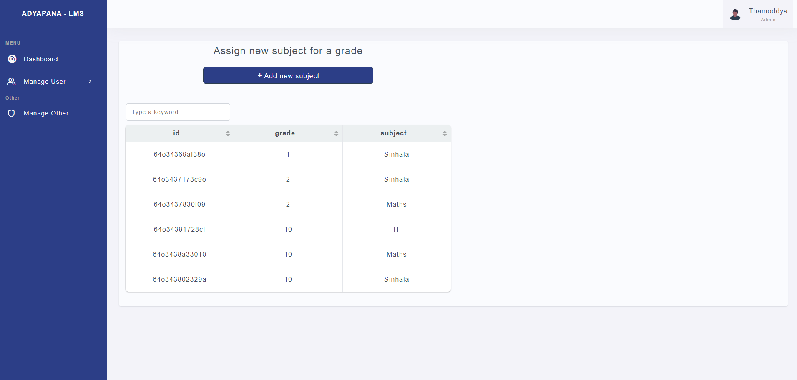

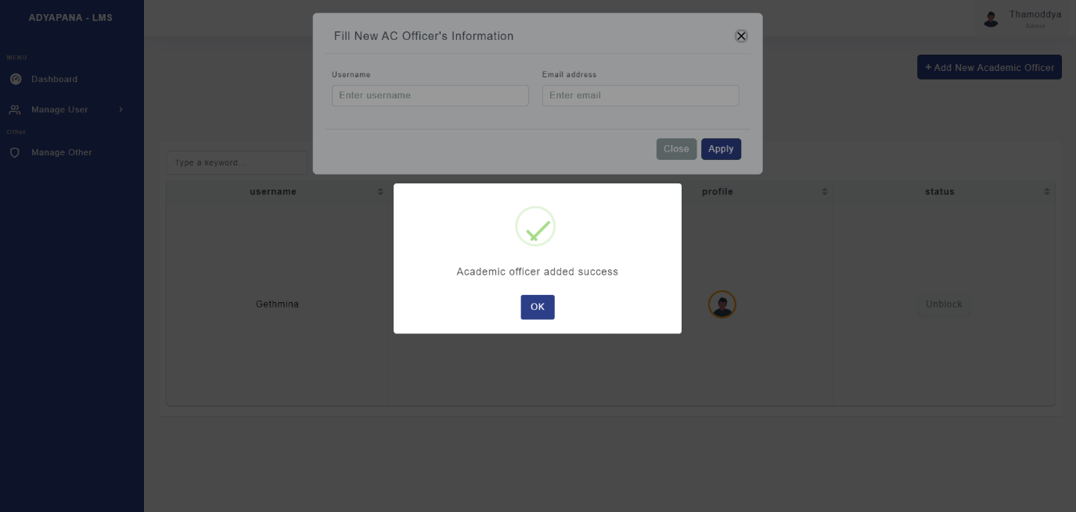

This screenshots shows all the methods ,

admin add academic,

admin adding new Subject for grade,

admin adding new Subject for grade,

admin adding teacher,

admin assign new job for teacher,

admin dashboard,

admin manage academic officer,

admin manage subject for grade,

admin manage teacher,

log out.

Academic adding successful.

This is academic Process screenshots,

academic officer adding new student,

academic officer dashboard,

academic officer manage student,

academic officer verifies student marks.

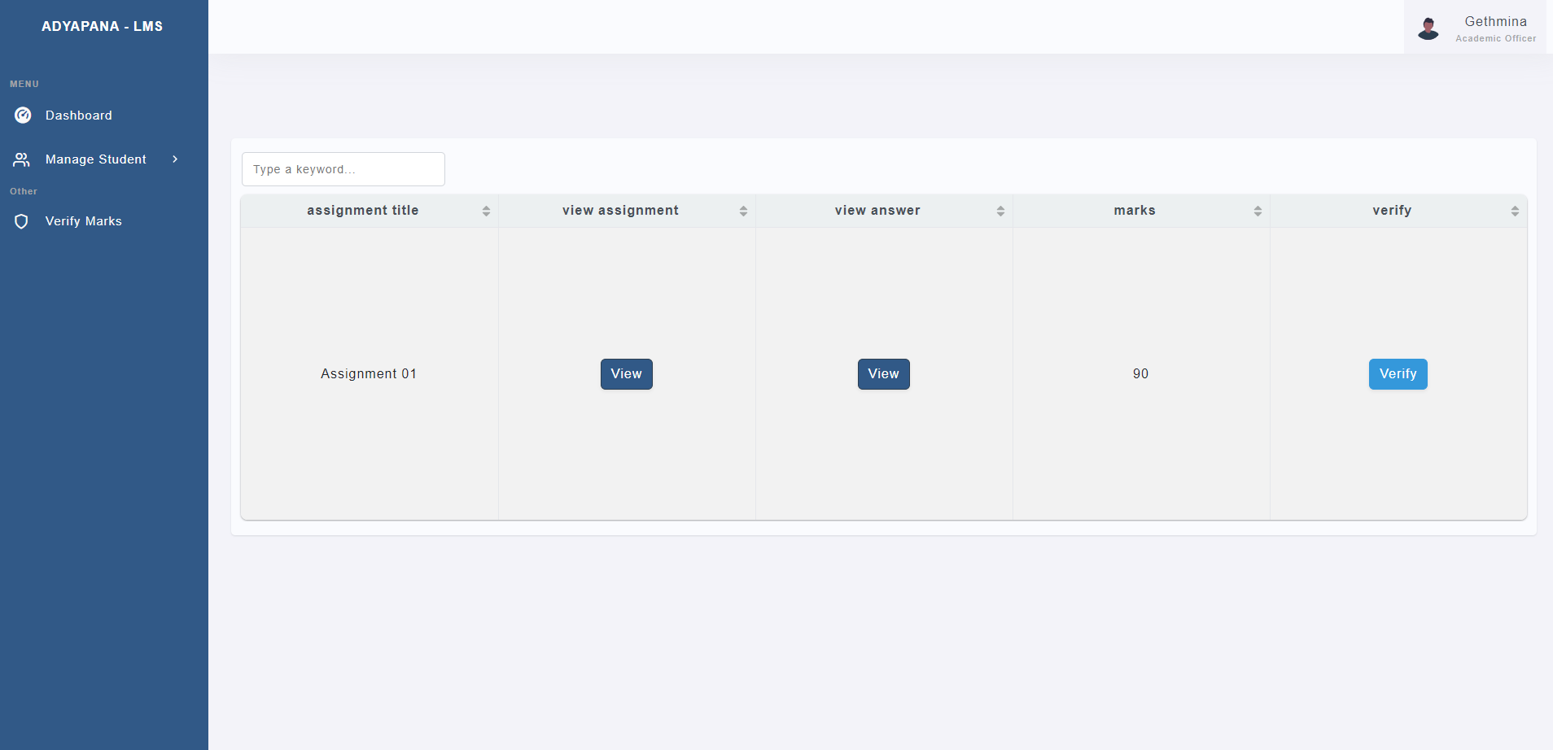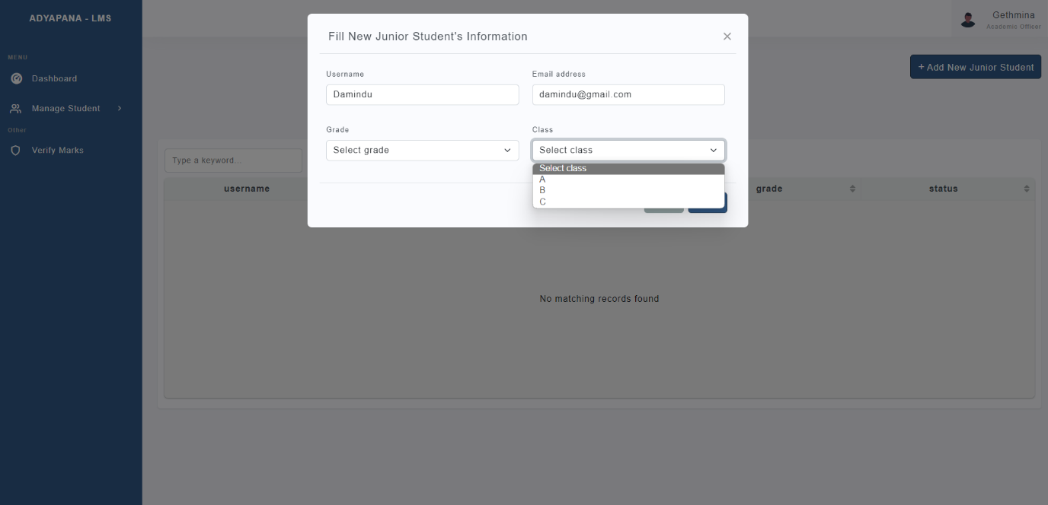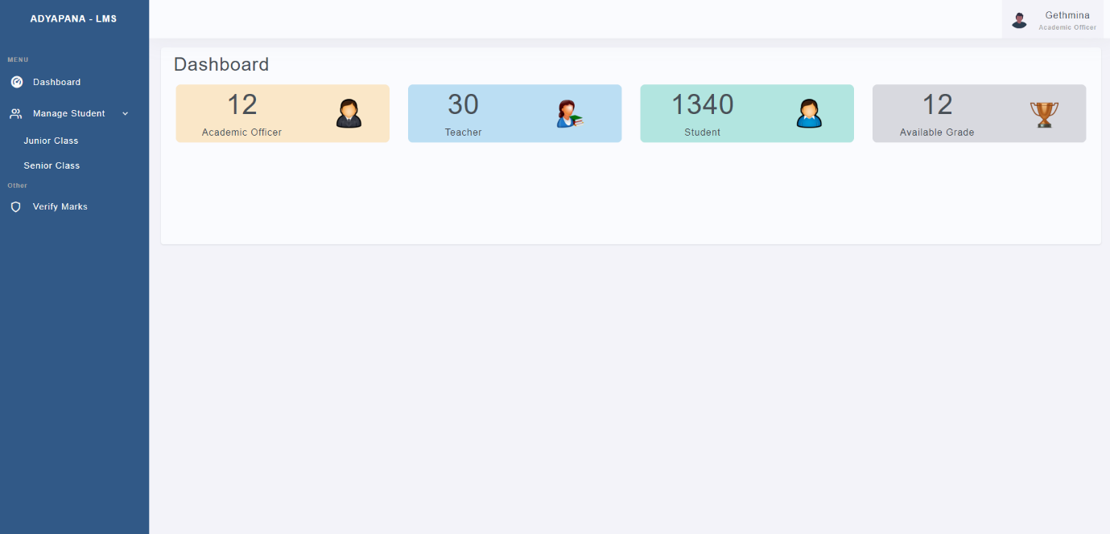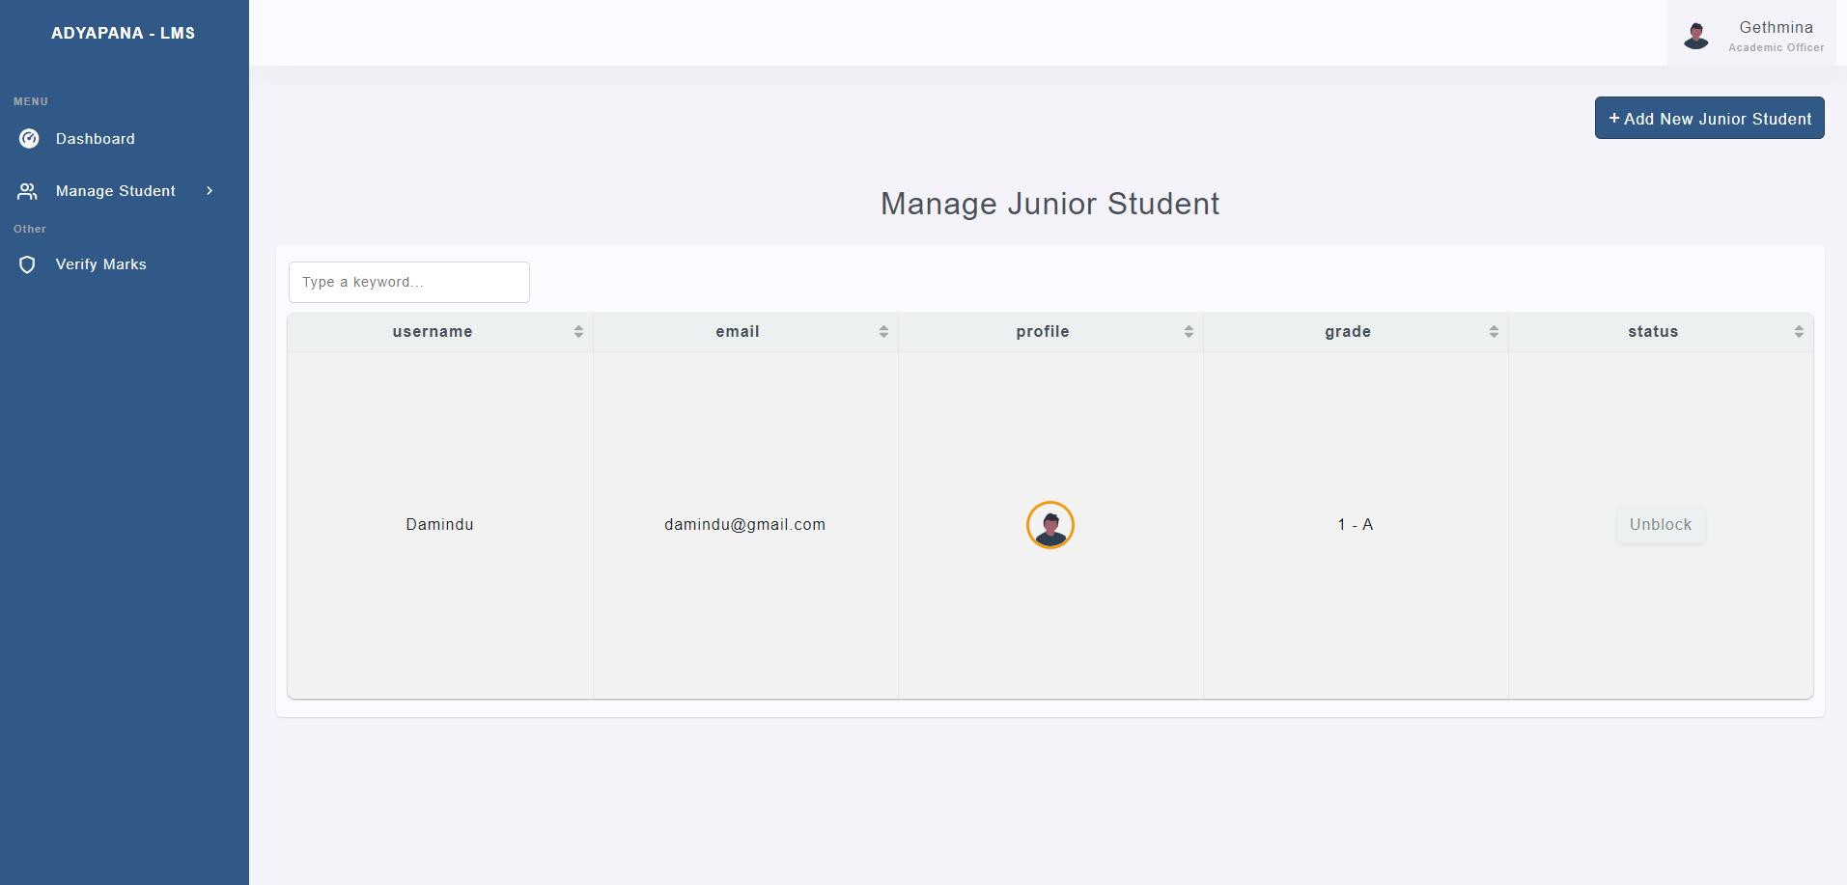

This is teacher Process screenshots,

teacher added successful,

teacher adding assignment answer sheet,

teacher adding assignment marks,

teacher adding new assignment,

teacher adding new note,

teacher dashboard,

teacher manage assignment marks,

teacher manage assignment,

teacher manage note,

teacher view assignment,

teacher view note

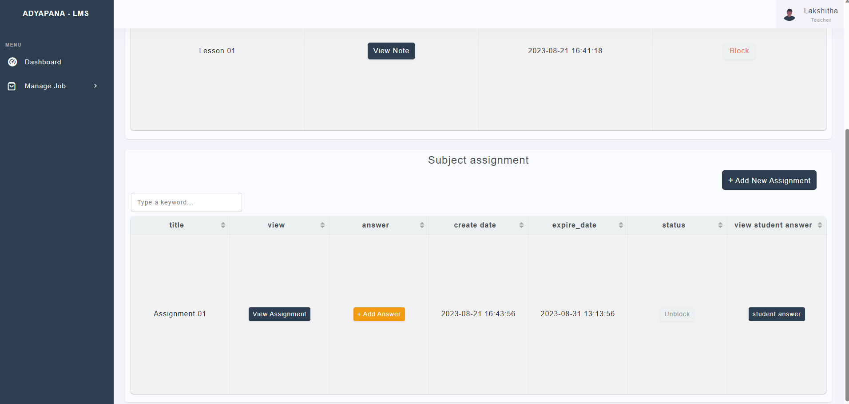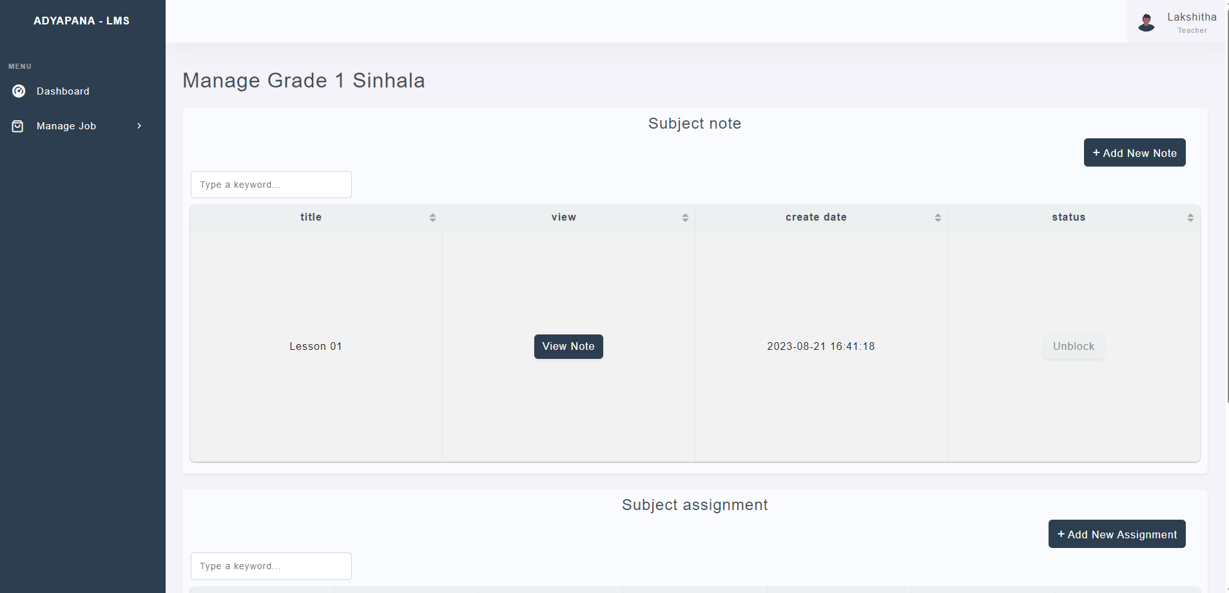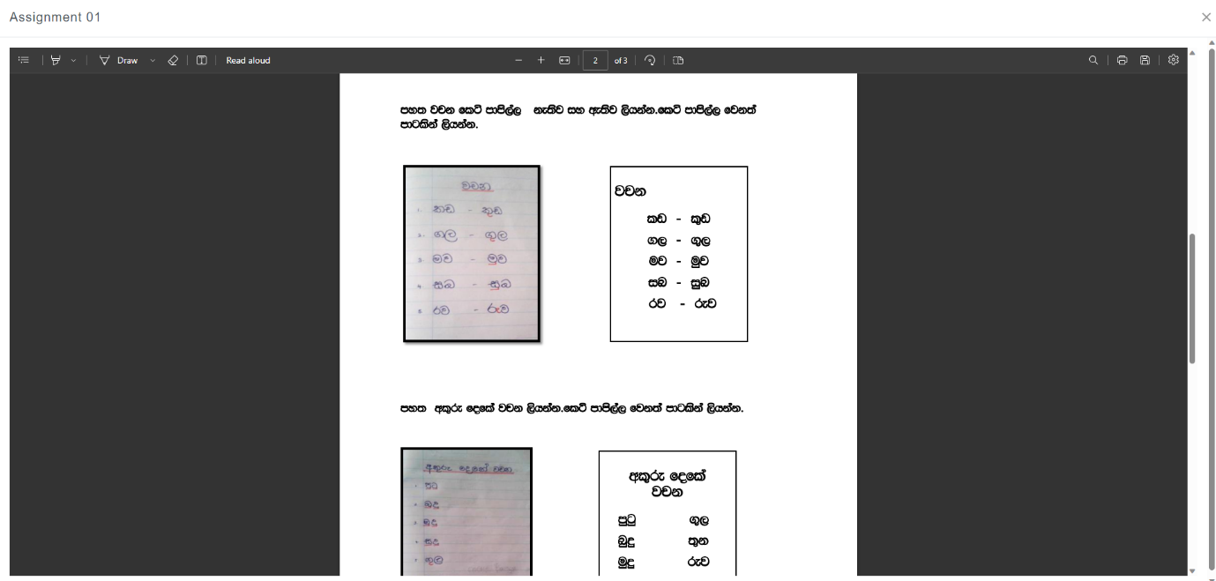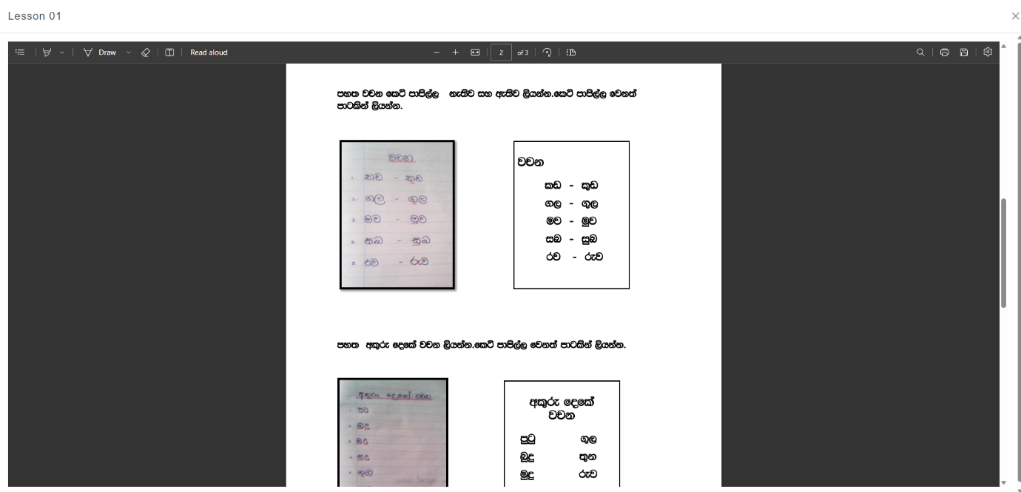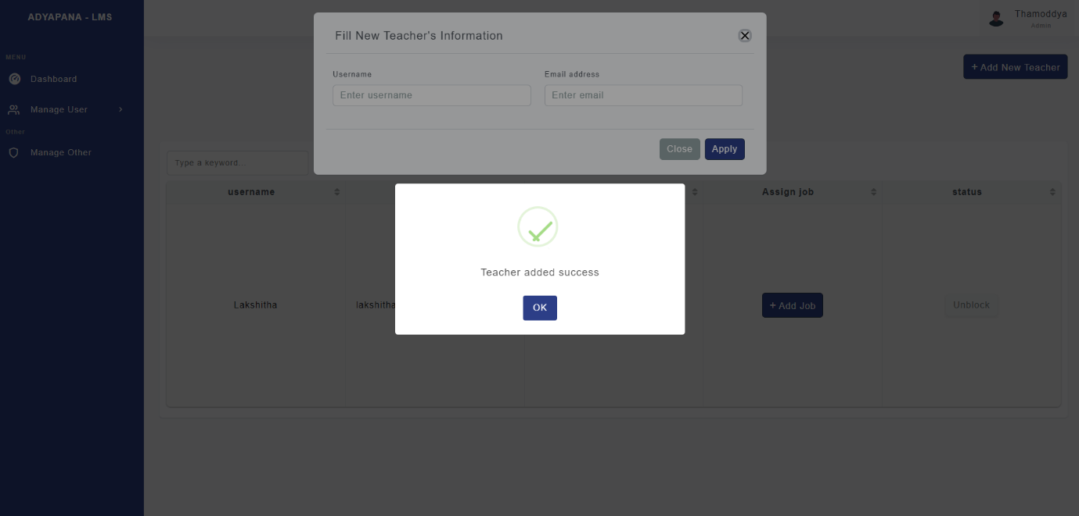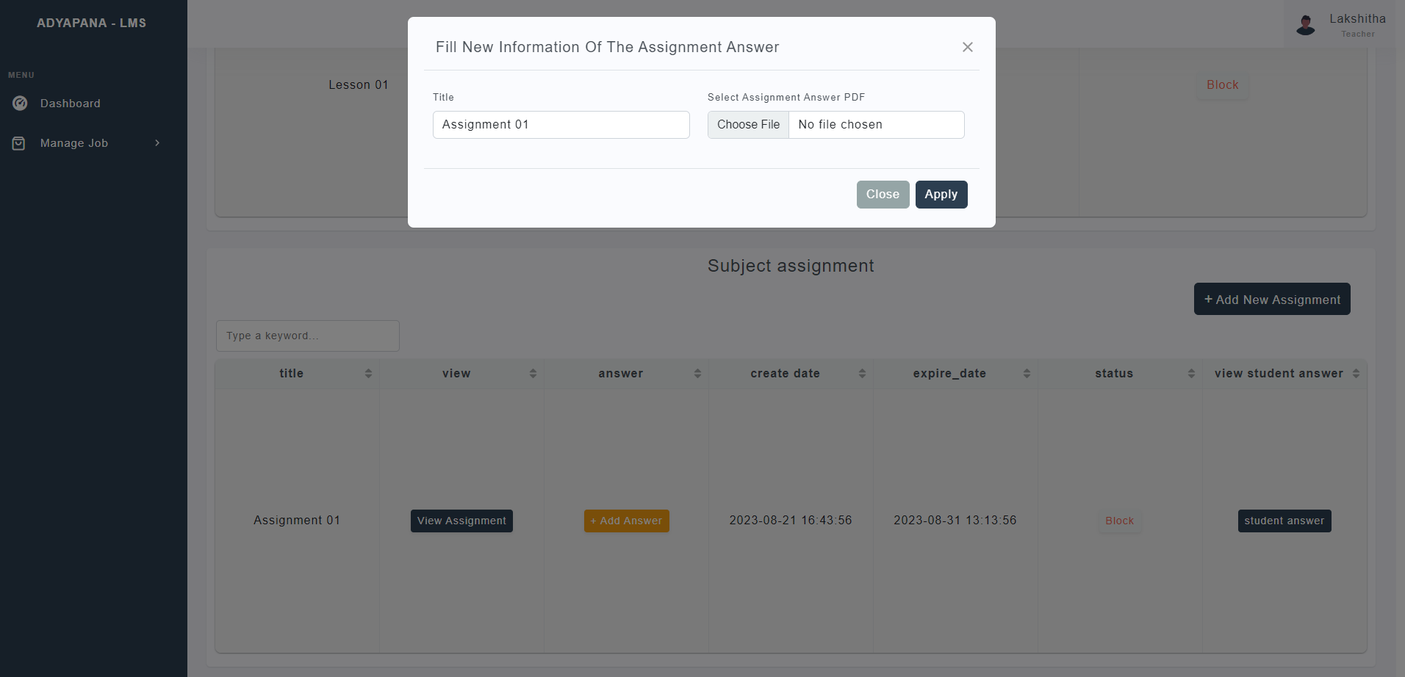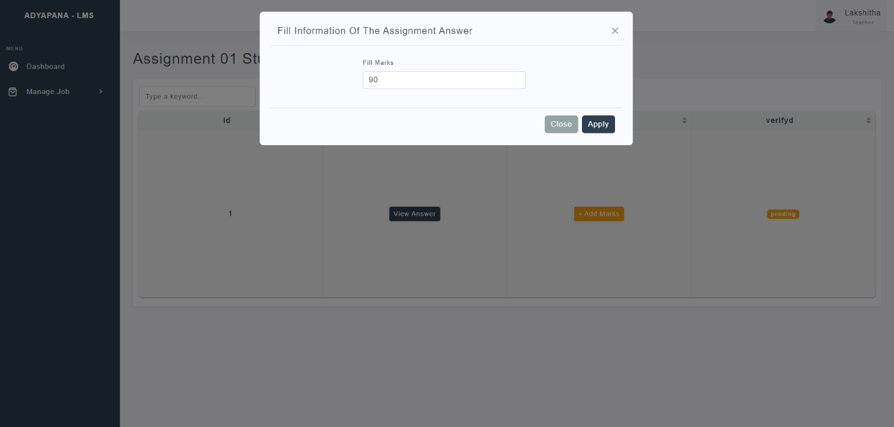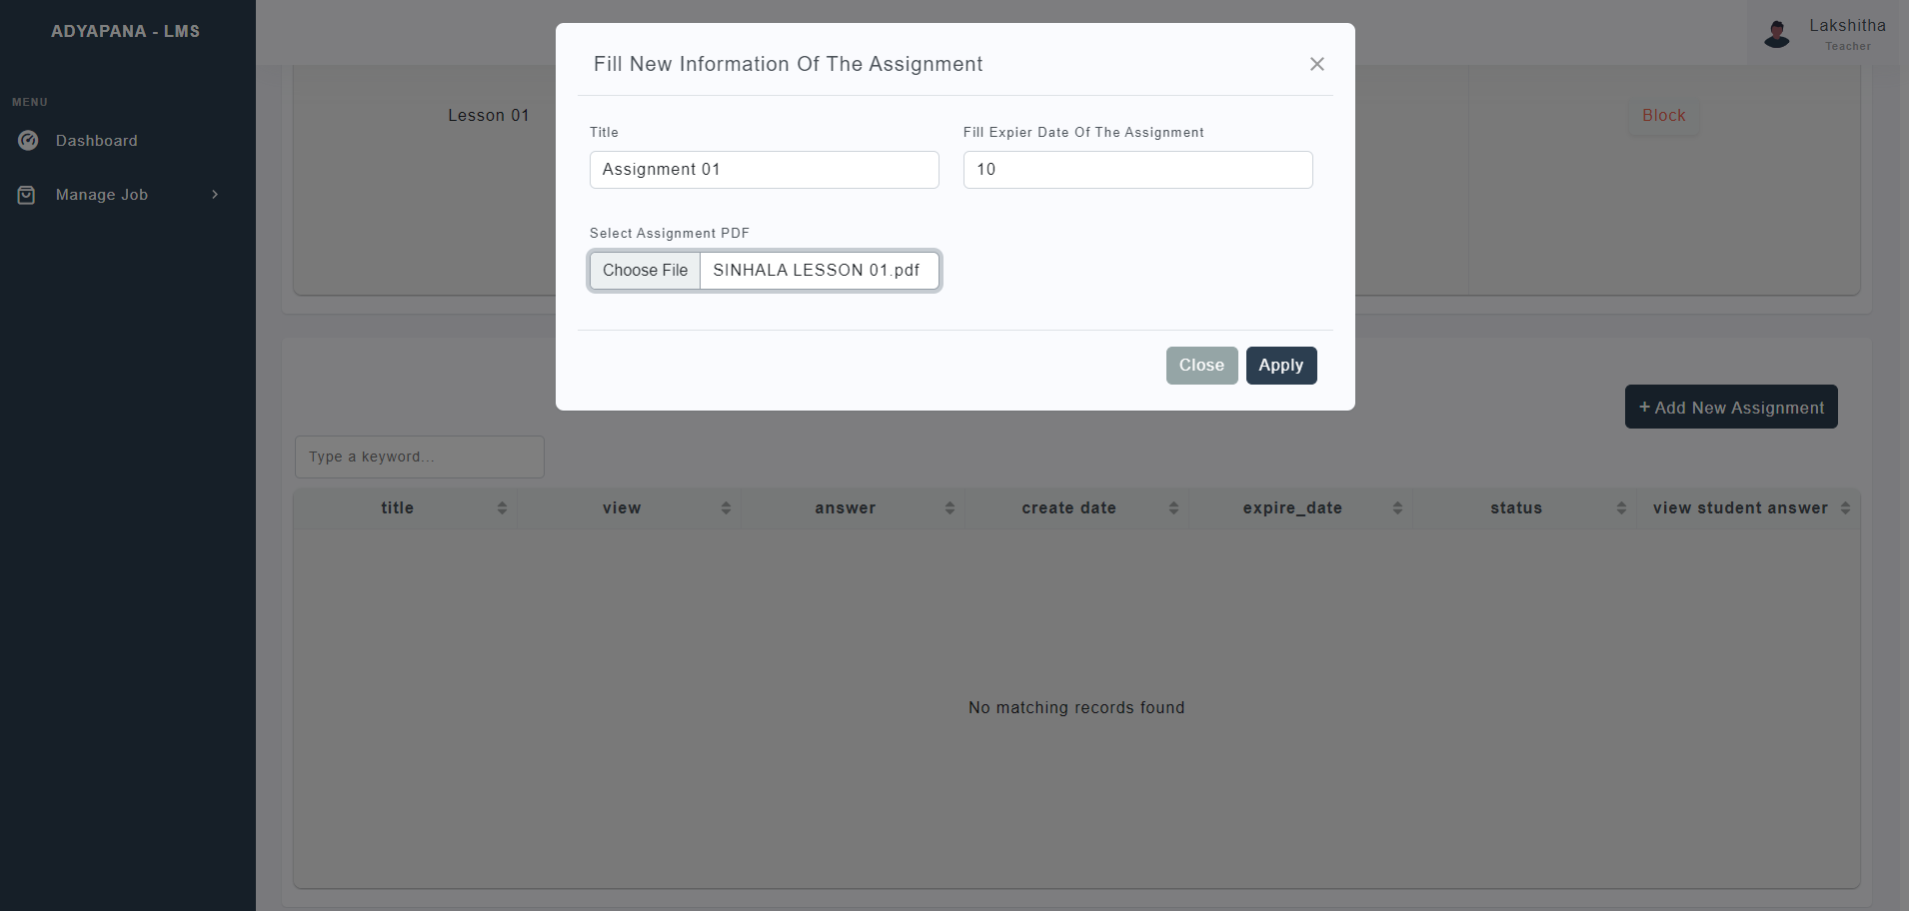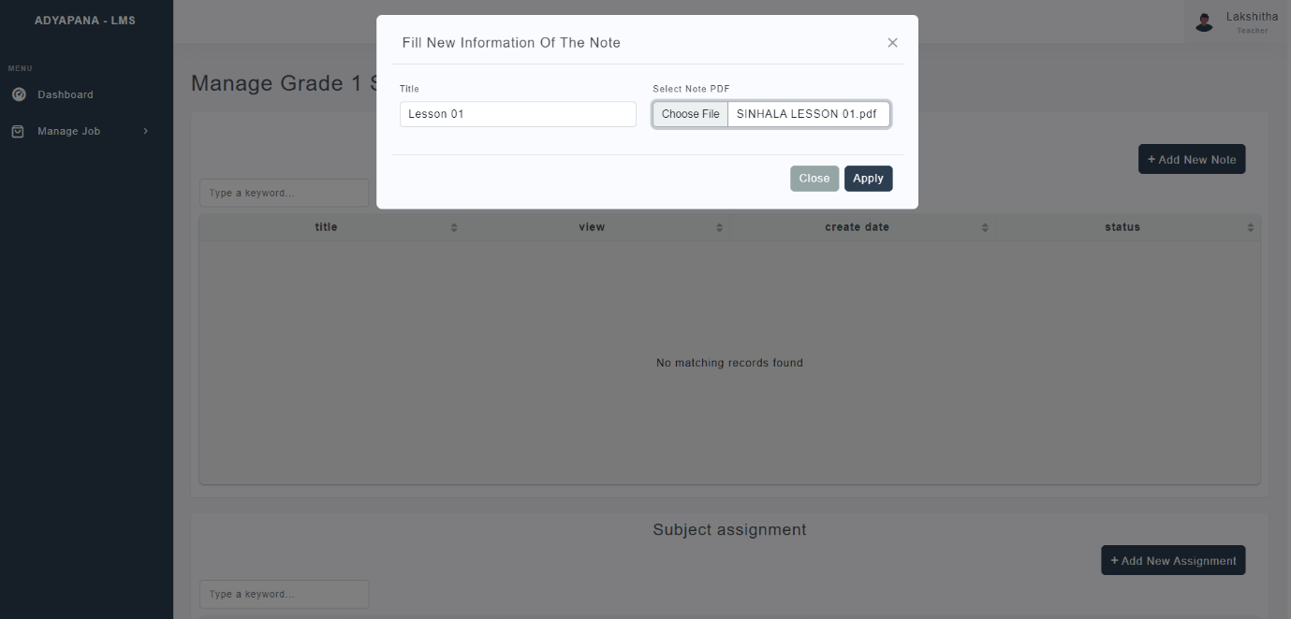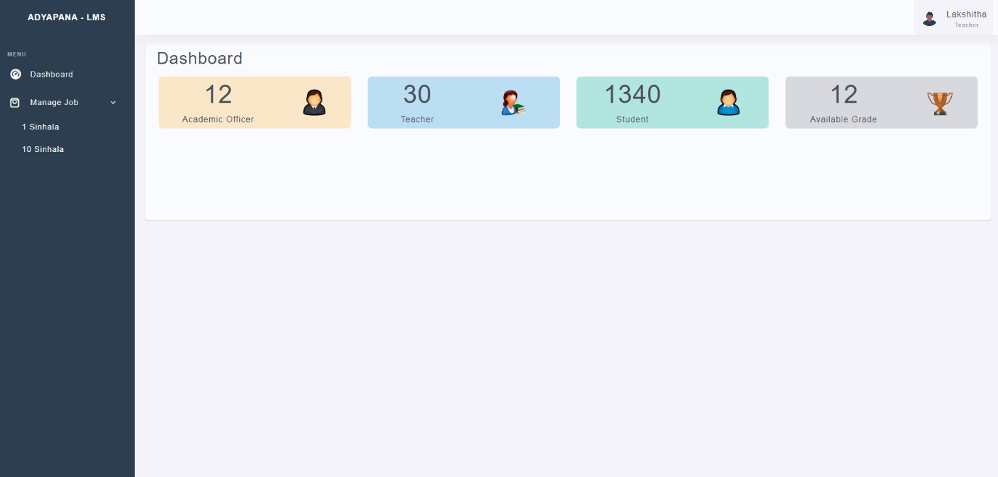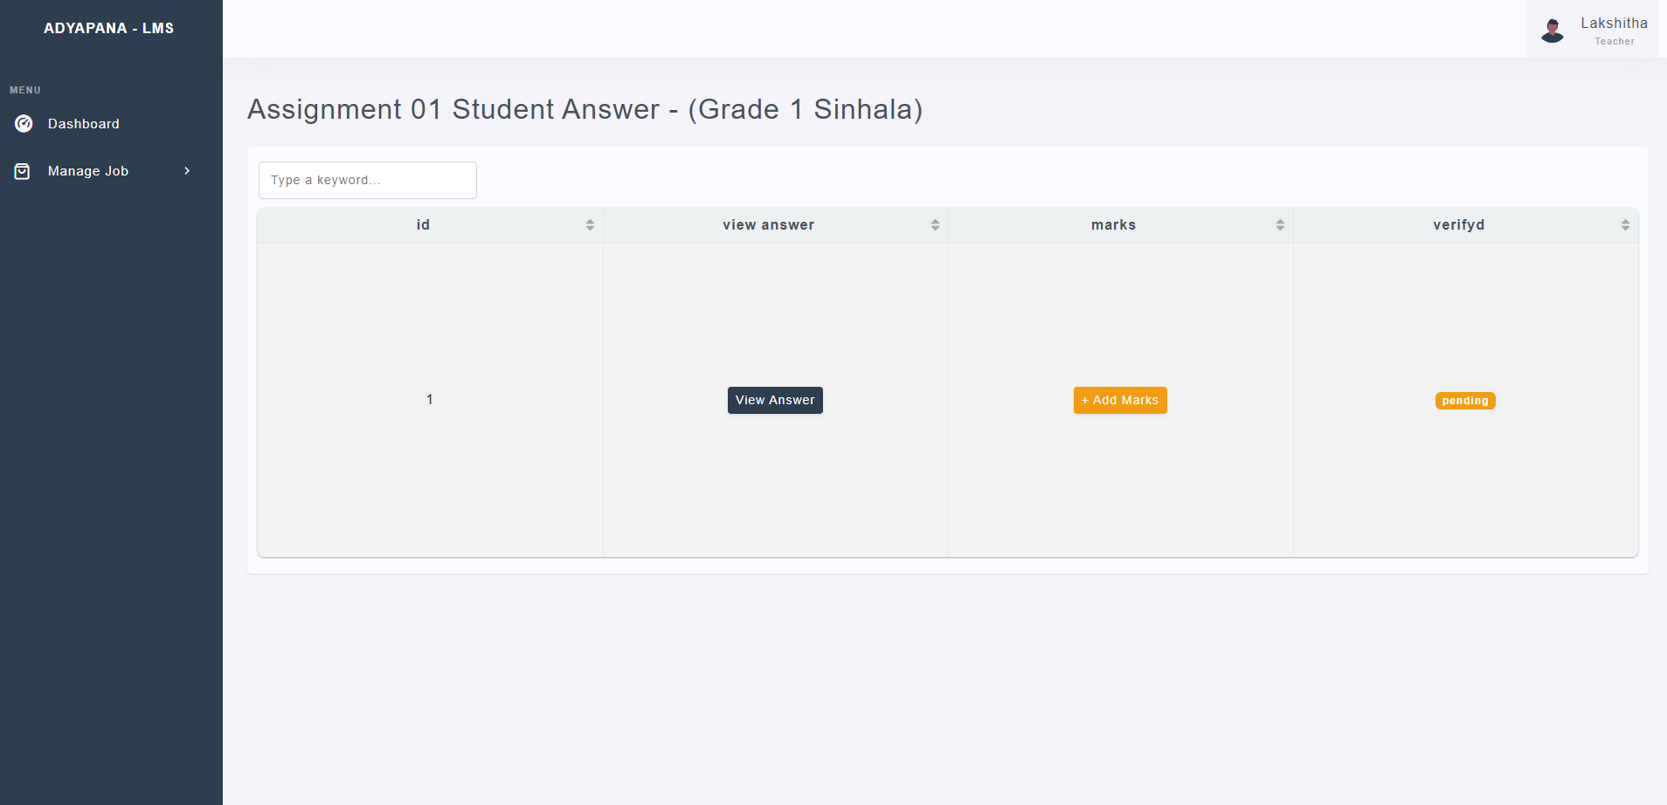

This is Student Process Screenshots,

student dashboard,

student manage assignment,

student manage subject note,

student payment page,

student upload answer for assignment,

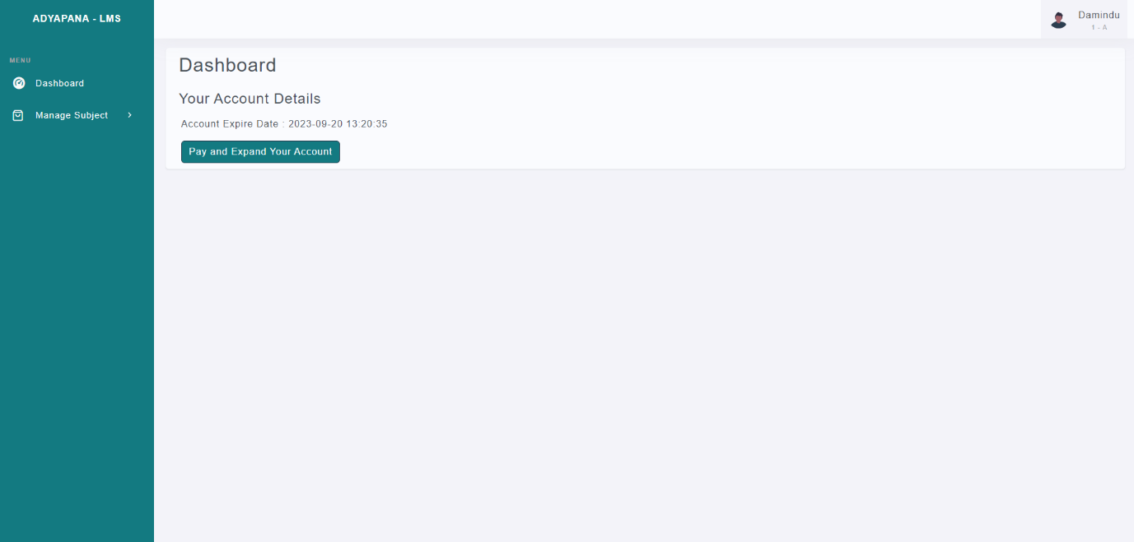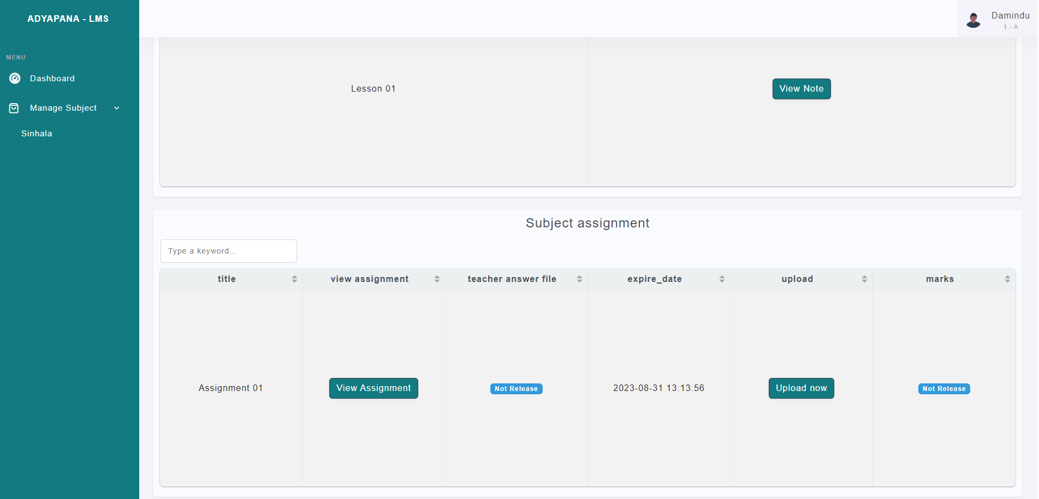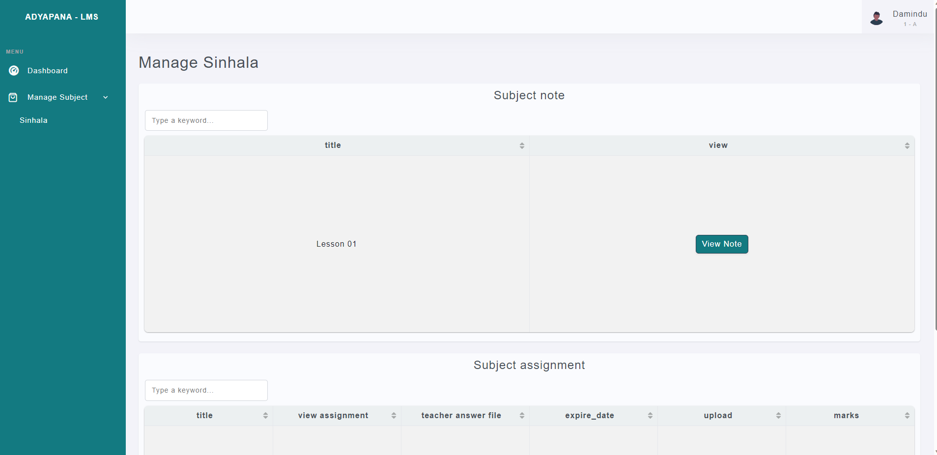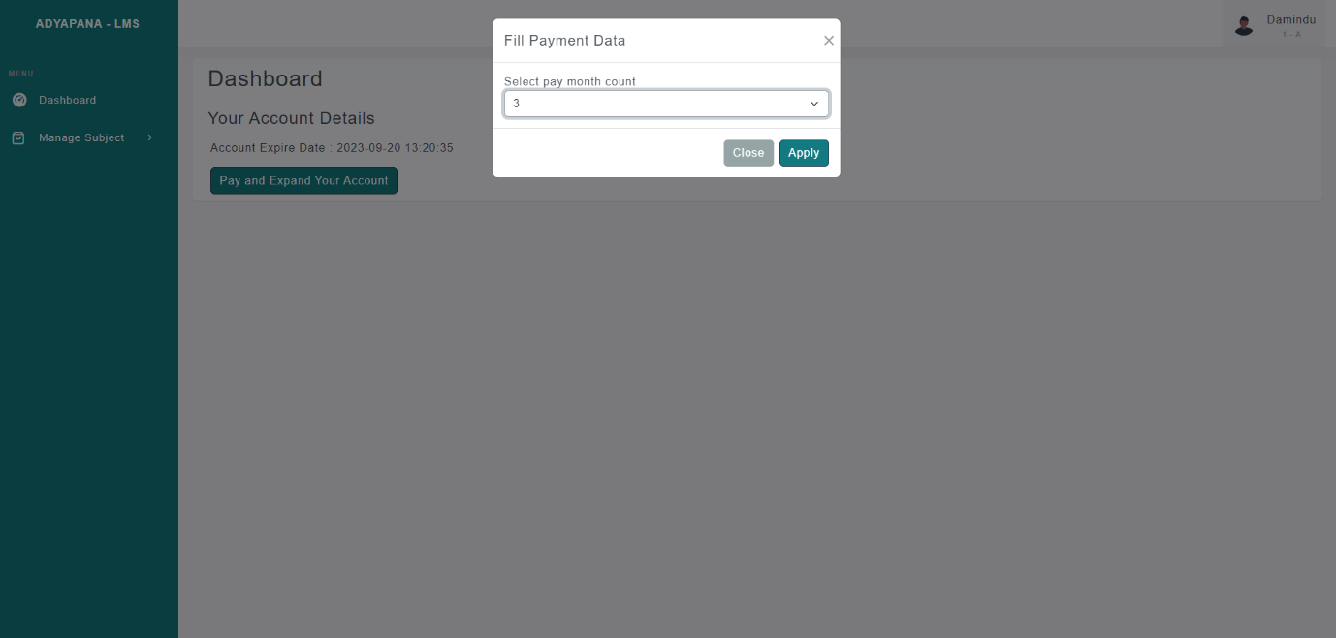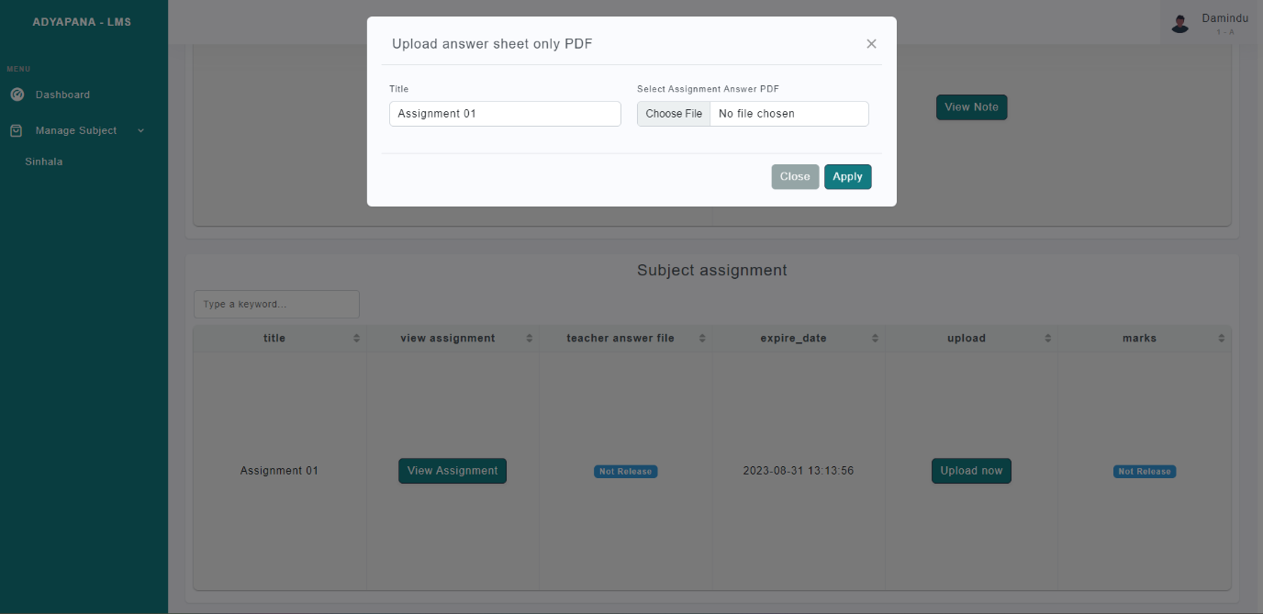

**OTHER**

Email :-



Verify Page: -

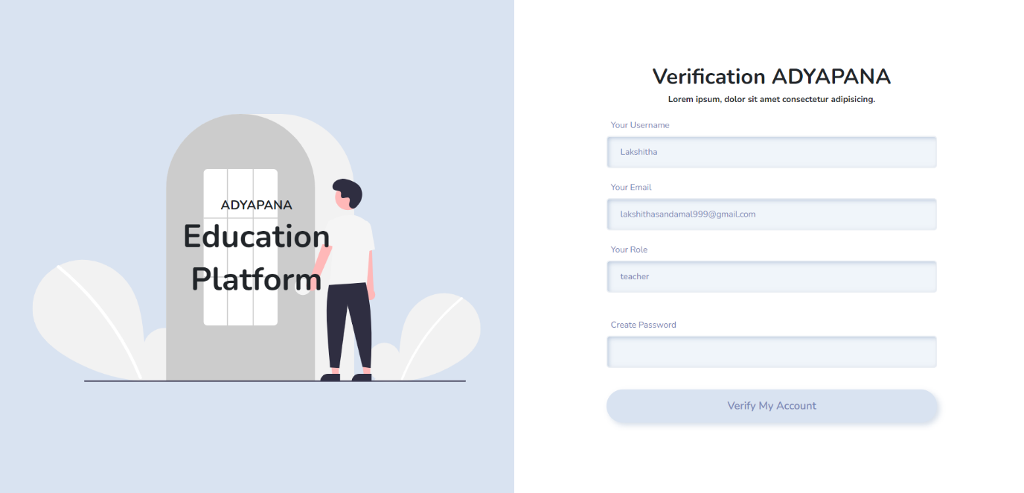

This is the whole LMS.The ER file and SQL file included with zip.

Thank You !